Towards TOMORROW

www.periit.com
Term: News Letter / Volume 11 / Issue date :July 2025

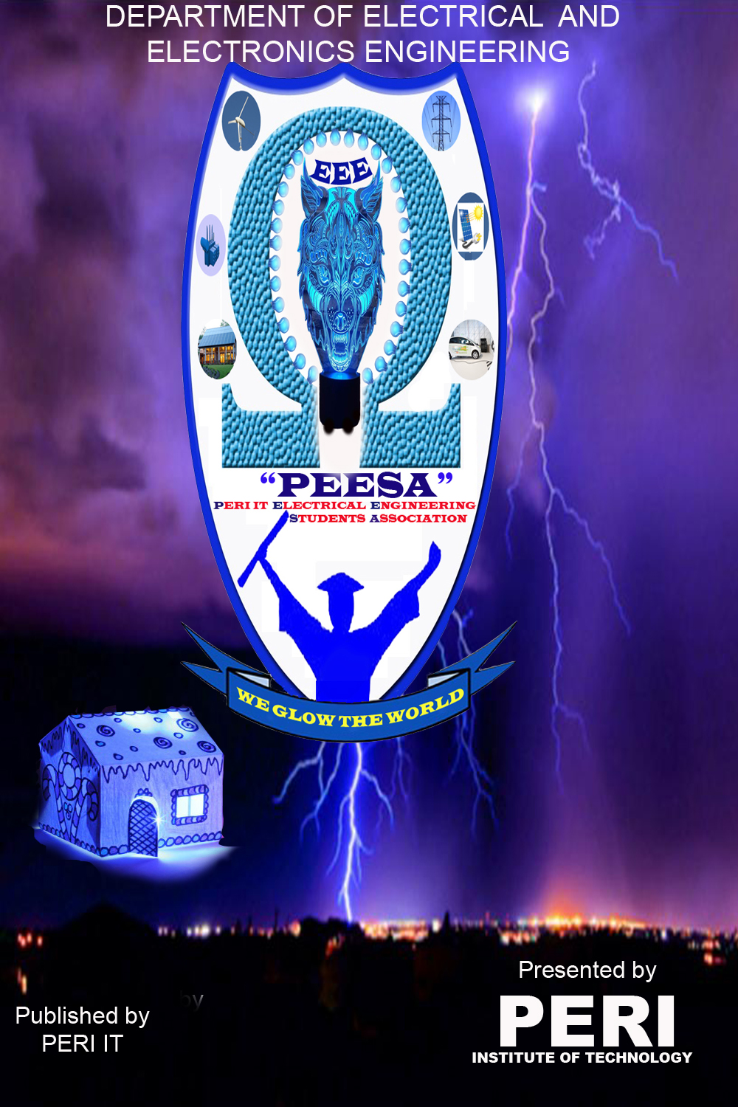

Greetings from the Dignitaries…

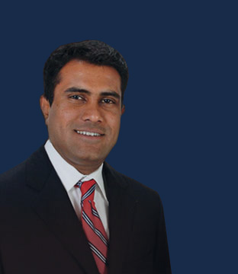

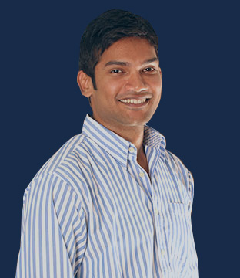

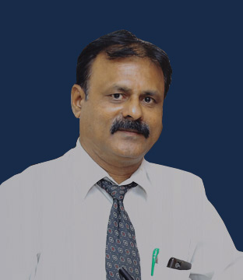

From our Chairman Sir…
I am proud to have students from Electrical and Electronics EngineeringDepartment to come up with such a good collection of information .I would like to encourage them
to continue their good work.

Mr. SARAVANAN PERIASAMY

Chairman, PERI Institute of Technology & CEO, PERI Software Solutions Inc., U.S.A.

Mr. SASIKUMAR VEERARAJAN

COO, PERI Institute of Technology

Dr.PALSON KENNEDY

Principal, PERI Institute of Technology

DEPARTMENT VISION:

To become a front-runner in bringing out competent Electrical and Electronics Engineers, innovators, researchers, and entrepreneur and thereby coontribute value to the knowledge-based economy and society.

DEPARTMENT MISSION:

- To offer good quality Under-Graduate, Post-Graduate and Doctoral programmes in electrical and electronics engineering.
- To provide state-of-the-art resources that contribute to achieve excellence in teaching-learning, research and development activities.
- To provide suitable forums to enhance the creative talents of students and faculty members.

- To enable students to develop skills to solve complex technological problems of current times and also provide a framework for promoting collaborative and multidisciplinary activities with moral values.

IINSIGHTS OF THE NEWSLETTER

- DEPARTMENTAL EVENTS
- National seminar
- GUEST LECTURE
- International conference
- INDUSTRIAL VISIT
- MOU SIGNED
- Bos meeting
- PLACEMENTACTIVITIES
- STAFF ACTIVITIES
- NPTEL COURSE COMPLETION
- Journal Publications
- Book publications
- FDP participation
- Patent Filing
- STUDENT ACTIVITIES
- CO-Curricular Activities
- Extra Curricular Activities
- Nptel course completion
- University & cat toppers

National seminar on RENEWABLE ENERGY TECHNOLOGY: OPTIMIZING ENERGY CONSUMPTION
”

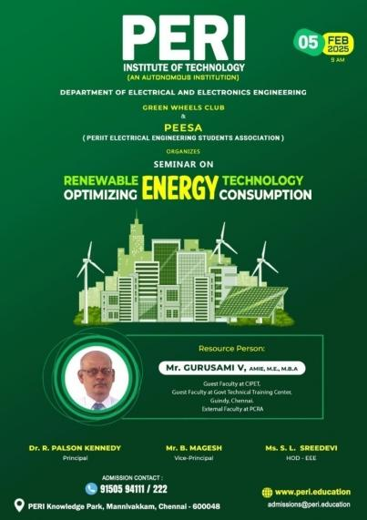 | 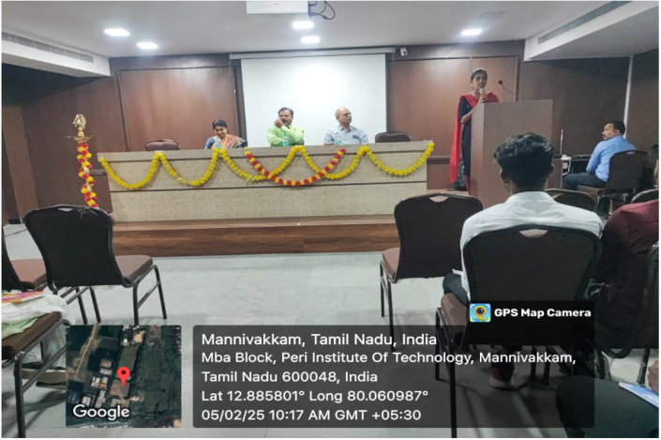

The Seminar on “Renewable Energy Technology: Optimizing Energy Consumption” was organized by the Department of Electrical and Electronics Engineering in connection with PERIIT Electrical Engineering Students Association (PEESA) and Green wheels club in the conference hall of the college premises for II, III and IV year students and staffs on 05-02-2025 at 09:00 a.m. It was inaugurated by Dr.Palson Kennedy, Principal, PERIIT and guest speaker Mr. V.Gurusami, Guest Faculty at CIPET & Govt Technical Training Center, Guindy, External Faculty at PCRA, Chennai. The Guest addressing the students with inspired speech on Renewable Energy Technology and how it helps in optimizing energy consumption.
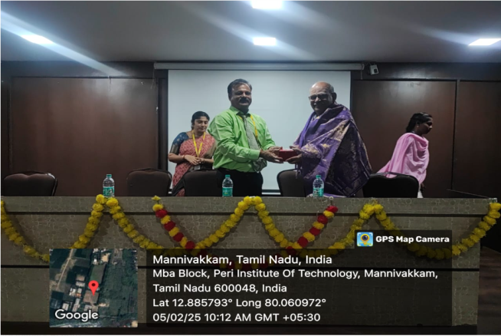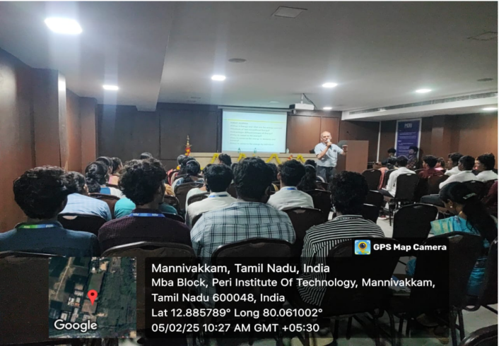

National Guest Lecture on MEP–Electrical Design for Commercial Building in Aesthetic Environment
”

POWERINFORMATION 18
No Resistance Can Drop our Potential

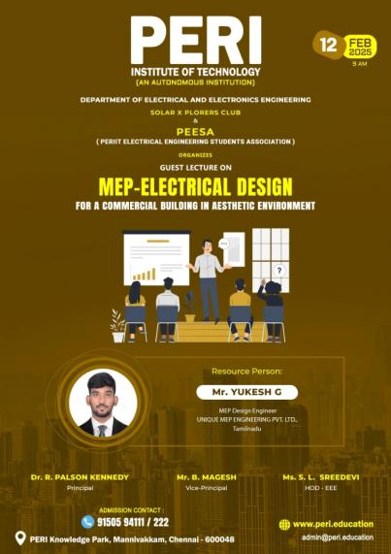 | 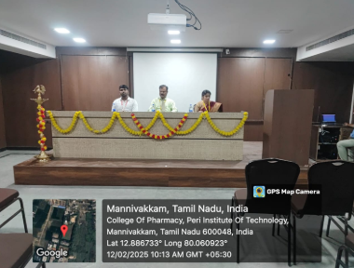

The Guest Lecture on “MEP–Electrical Design for Commercial Building in Aesthetic Environment” was organized by the Department of Electrical and Electronics Engineering in connection with PERIIT Electrical Engineering Students Association (PEESA) and Solar X- Plorers club in the conference hall of the college premises for II, III and IV year students and staffs on 12-02-2025 at 09:00 a.m. It was inaugurated by Dr.Palson Kennedy, Principal, PERIIT and guest speaker Mr. G.Yukesh, MEP Design Engineer, Unique MEP Engineering Academy Pvt. Ltd, Chennai. The Guest addressing the students with inspired speech on the integration of mechanical, electrical, and plumbing (MEP) systems, specifically the electrical aspects, within aesthetically designed commercial buildings.
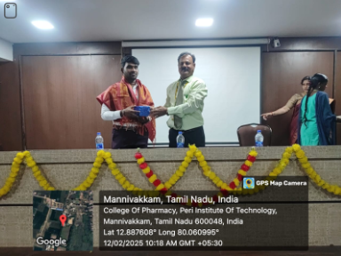 | 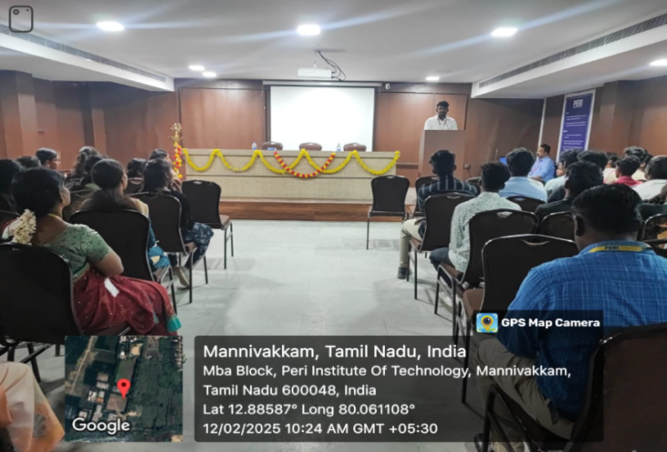

National seminar on BIM for Electrical Infrastructure Design
”

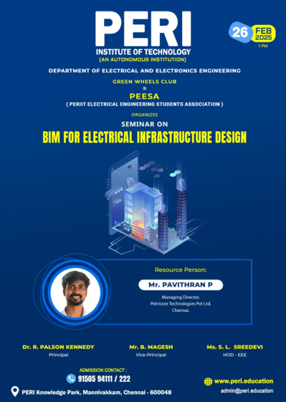 | 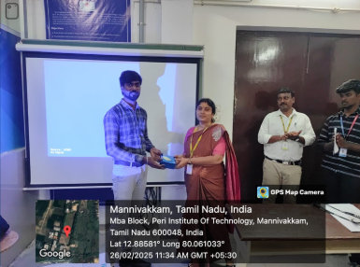

The Seminar on “BIM for Electrical Infrastructure Design” was organized by the Department of Electrical and Electronics Engineering in connection with PERIIT Electrical Engineering Students Association (PEESA) and Green wheels club in the conference hall of the college premises for II, III and IV year students and staffs on 26-02-2025 at 01:00 p.m. It was inaugurated by Dr.Palson Kennedy, Principal, PERIIT and guest speaker Mr.P.Pavithran, Managing Director, Petricore Technologies Pvt. Ltd, Chennai. The Guest addressing the students with inspired speech on BIM (Building Information Modeling) in electrical infrastructure design. BIM transforms the electrical design process from a two-dimensional, linear approach to a collaborative, data-rich, and visually-driven process.
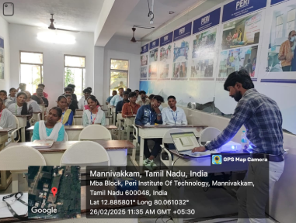 | 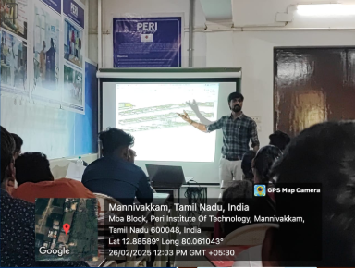

technical events on RENEWIT’25

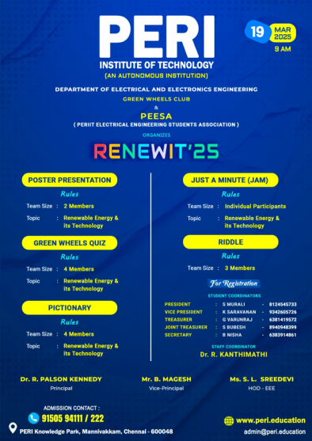 | 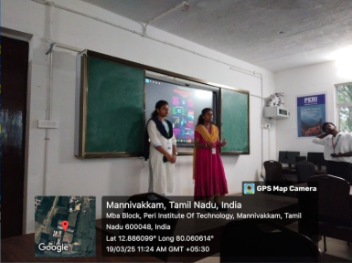

The technical events on “RENEWIT’25” were organized by the Department of Electrical and Electronics Engineering in connection with PERIIT Electrical Engineering Students Association (PEESA) and Green Wheels club in the conference hall of the college premises for I, II, III and IV year students of all departments on 19-03-2025 at 09:00 a.m. It was inaugurated by Dr.Palson Kennedy, Principal, PERIIT and Dr.R.Rajeswari, HoD, Electronics and Communication Engineering. During this technical event, we successfully hosted a variety of engaging competitions designed to foster innovation and quick thinking among participants.
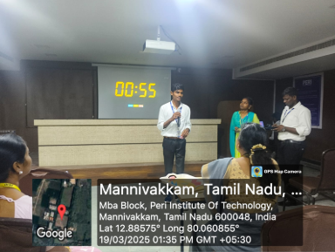 | 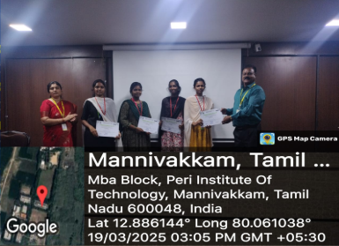

Alumni Connect – 2025 (Online meet) on Powering the Future: A Practical Approach to PV System Design
”

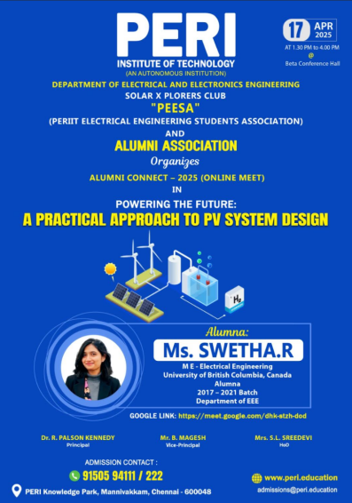 | 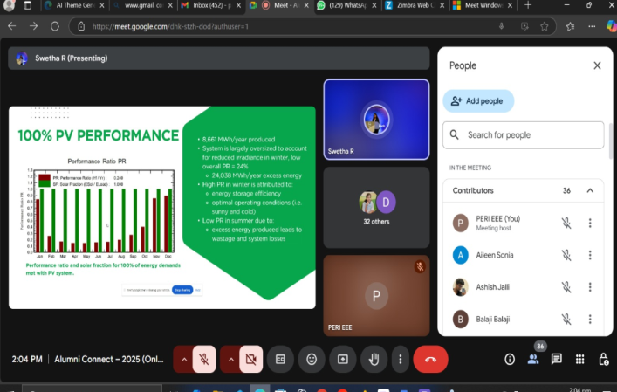

The Alumni Connect – 2025 (Online meet) on “Powering the Future: A Practical Approach to PV System Design” was organized by the Department of Electrical and Electronics Engineering in connection with PERIIT Electrical Engineering Students Association (PEESA), Solar X- Plorers club and Alumni association in the conference hall of the college premises for II, III and IV year students and staffs on 17-04-2025 at 01:30 p.m. It was inaugurated by Dr.Palson Kennedy, Principal, PERIIT and guest speaker Ms.R.Swetha, PG Student, University of British Columbia, Canada, Alumna, 2017- 2021 Batch, EEE. The Guest addressing the students with inspired speech on photovoltaic (PV) system implementation. The speaker meticulously outlined the essential stages of PV design, beginning with a critical emphasis on accurate load calculation to determine energy requirements.
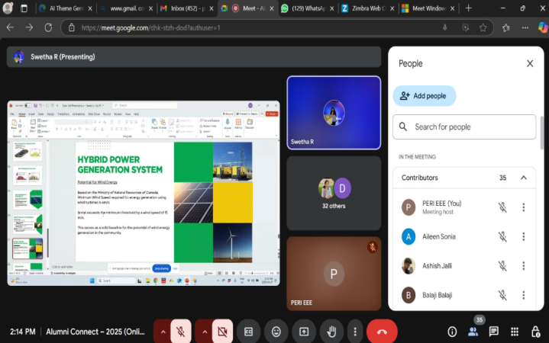 | 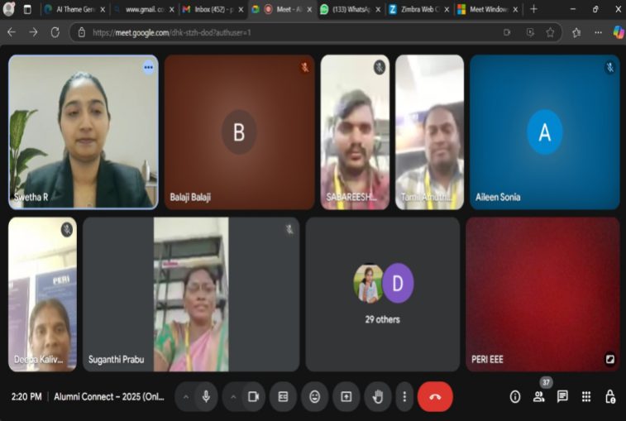

INTERNATIONAL CONFERENCE ON ELECTRICAL ELECTRONICS AND COMMUNICATION TECHNOLOGY - ICEECT'25

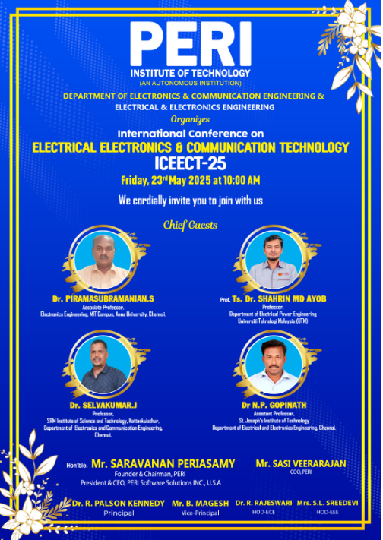 | 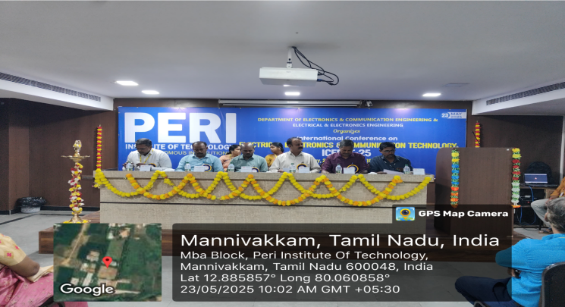  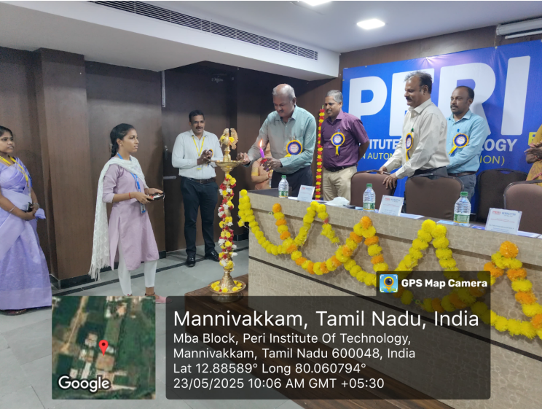

Department of Electronics and Communication Engineering and Electrical and Electronics Engineering organized the International conference on Electrical Electronics and communication Technology ICCEECT’25 on 23rd May 2025. The chief guests are Dr.S.Piramasubramanian, Associate Professor, Electronics Engineering, MIT Campus, & Prof.Ts.Dr.Shahrin Md. Ayob, Electrical Engineering, Universiti Teknologi Malaysia. The conference aimed to foster collaboration, knowledge exchange, and discussions on cutting-edge research, emerging technologies, and practical applications in the fields of electrical engineering, electronics, and communication technology. Students from various institutions participated in ICEECT'25, showcasing their research and innovative projects in the fields of electrical, electronics, and communication technology. Their contributions were highly recognized, and several students were awarded prizes for their outstanding work.

The participants claimed their queries to the resource person related to the topic of discussion. They were all addressed by the speaker in a realistic manner. The speaker gave a few guidelines to advance study in PLC programming and automation in efficient manners.

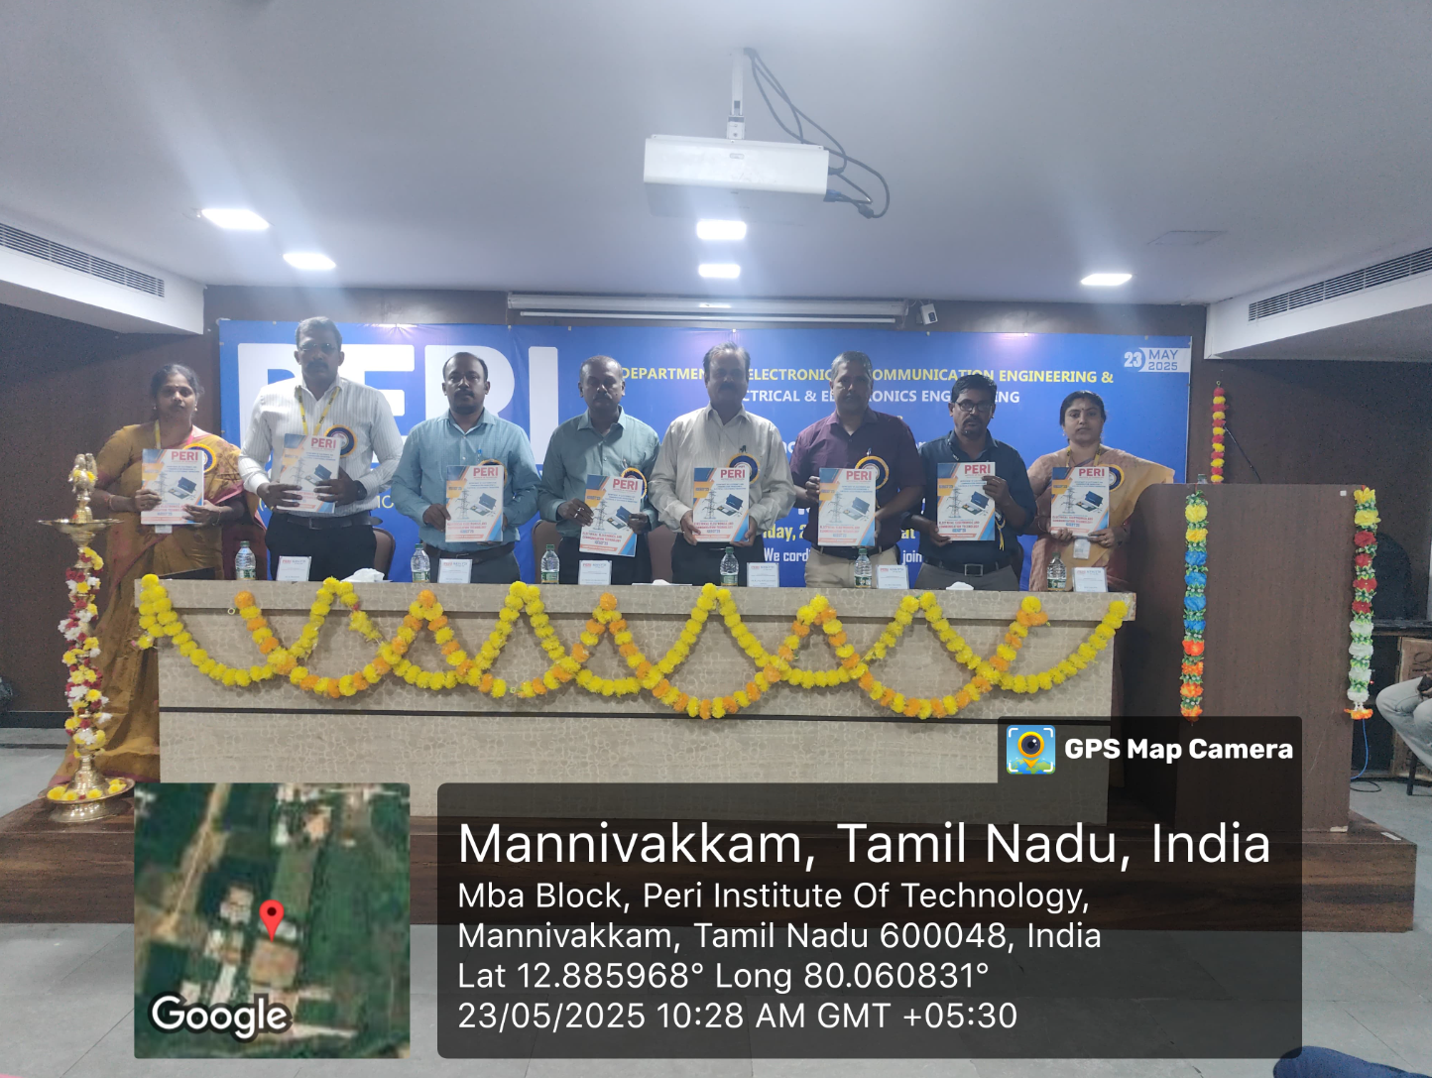

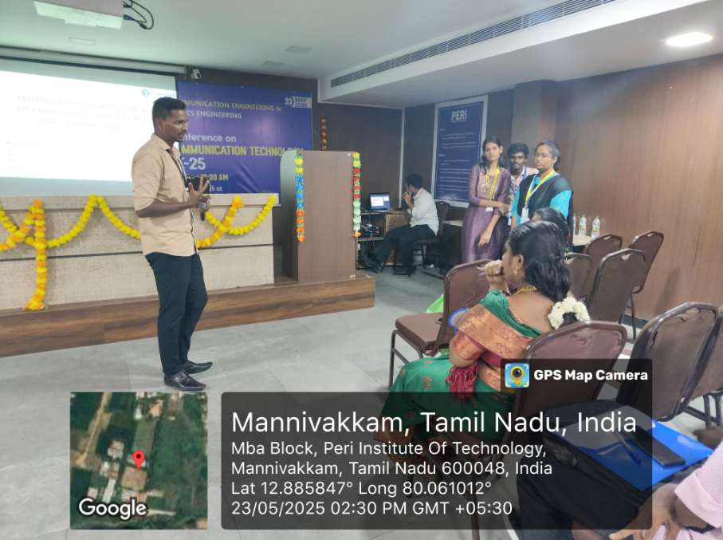

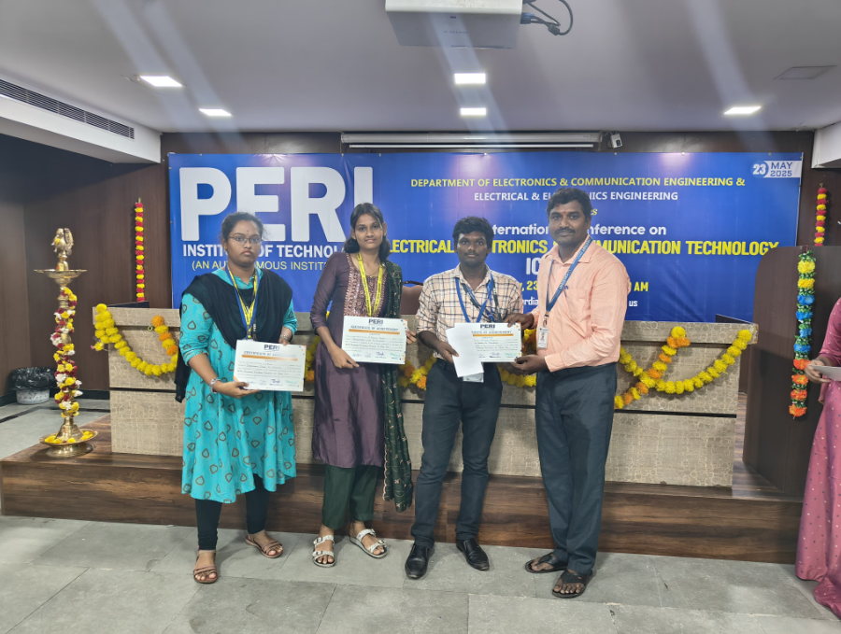

INDUSTRIAL VISIT TO Garuda Aerospace Pvt Ltd

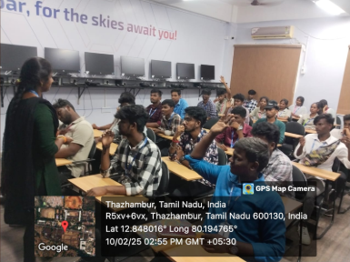
Students at Garuda Aerospace Pvt Ltd, Chennai
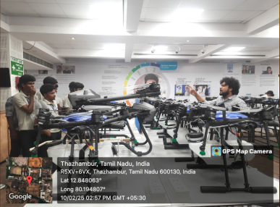
An industrial visit to Garuda Aerospace Pvt Ltd, Chennai was organized on 10-02-2025 by Mrs. S.L. Sreedevi,HOD-EEE of PERIIT. Under the guidance of Dr. S.Suganthi, Assistant Professor the industrial visit was a Grand success conducted exclusively for the students of third, final year EEE students. During the visit, students explored the company's advanced manufacturing processes, innovative product designs, and state-of-the-art technology solutions.
Industrial visit – Maraimalai Nagar 230/110 KV Substation

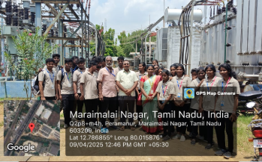
Students learn about the equipment used in 230/110kV substation
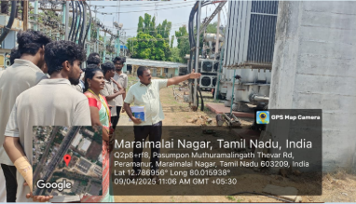

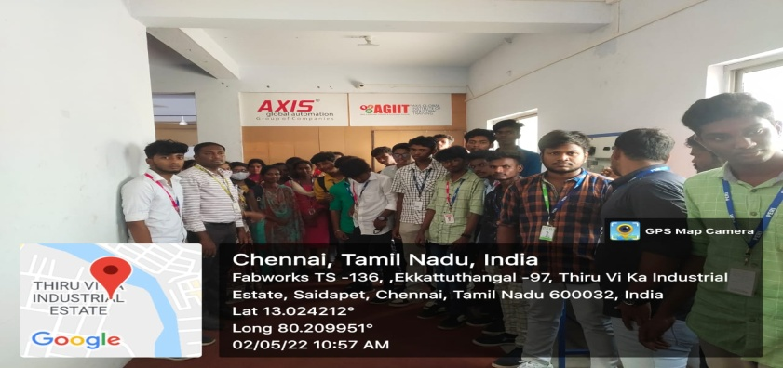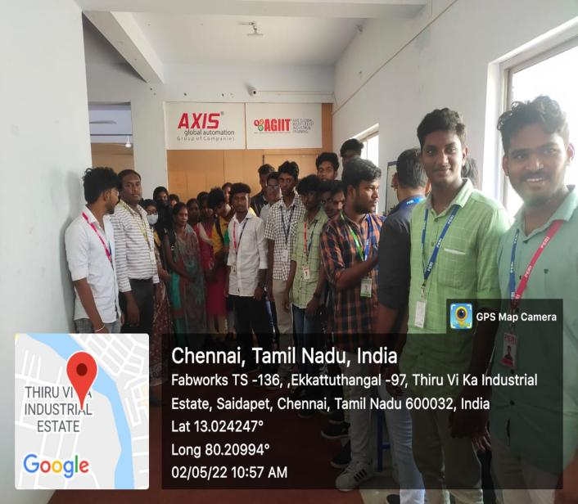
A one-day industrial visit to 230/110KV Substation, Maraimalai Nagar was organized on 09-04-2025 by Mrs. S.L. Sreedevi,HOD-EEE of PERI IT. Under the guidance of Dr. S.Suganthi, Assistant Professor the industrial visit was a Grand success conducted exclusively for the students of third, final year EEE students. During the visit, students observed the operation of transformers, circuit breakers, and other critical substation components, gaining insights into the transmission and distribution of electricity.

MOU SIGNED

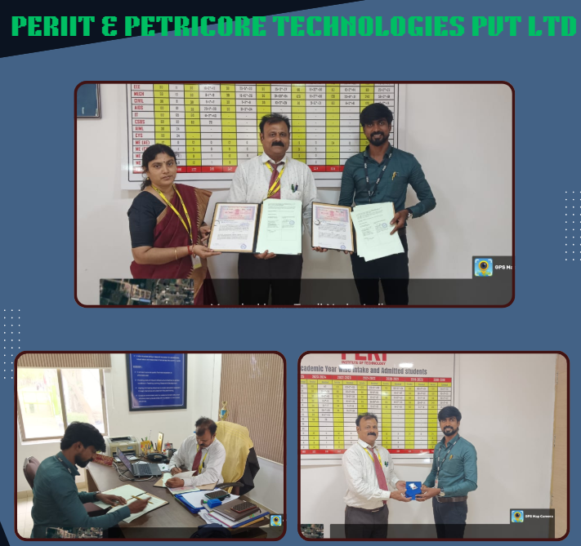

PERIIT has signed a Memorandum of Understanding (MOU)
with Petricore Technologies and Engineering Services (P) Ltd,
Chennai on 07-04-2025.
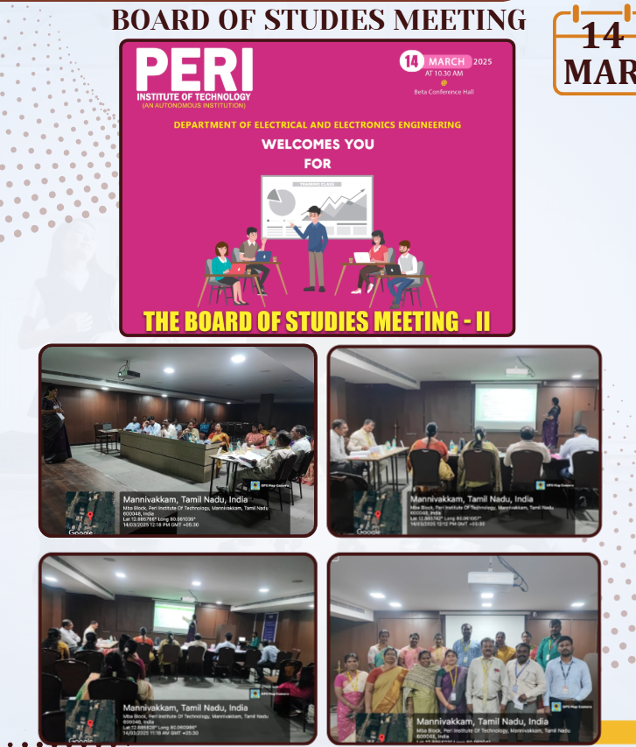
CONSOLIDATED REPORT OF PLACED STUDENTS FOR THE
YEAR 2024 – 25 (EVEN SEM)

S.No | Reg. No | Name of the Student | Placed Company Name | Salary Package  (Per Annum)
1 | 411521105002 | Bubesh S | Salcomp, Sriperumbudur, Chennai | 3 L
2 | 411521105011 | Murali S | Ingenious network India Pvt. Ltd, Chennai | 2.2 L
3 | 411521105015 | Pothigachalam U | TechForce Services, Chennai | 5 L
4 | 411521105017 | Priyanka M | Formoplastic Controls Pvt. Ltd, Madhanandapuram, Chennai | 2.5 L
5 | 411521105018 | Sabitha S | Formoplastic Controls Pvt. Ltd, Madhanandapuram, Chennai | 2.5 L
6 | 411521105019 | Samy K | Seoyon E- Hwa, Chennai | 2.2 L
7 | 411521105020 | Saravanan K | Salcomp, Sriperumbudur, Chennai | 3 L
8 | 411521105021 | Shasidharan K | Inspire AI, Bangalore | 5.2 L
9 | 411521105023 | Thivya S | Excelencia, Ascendas International Tech park, Tharamani, Chennai | 3.5 L
10 | 411521105024 | Varunraj G | Seoyon E- Hwa, Chennai | 2.2 L
11 | 411521105025 | Vinayaga Moorthy M | Seoyon E- Hwa, Chennai | 2.2 L
12 | 411521105305 | Kamaraj.K | Formoplastic Controls Pvt. Ltd, Madhanandapuram, Chennai | 2.5 L
13 | 411521105312 | Sethuraman | Seoyon E- Hwa, Chennai | 2.2 L

STUDENT NPTEL Online CERTIFICATION Details

S.No | Name of the Student | Year | Name of the course | Duration
1 | Aathinarayanan.G | III | Introduction to Industry 4.0 and Industrial IoT | 12 Weeks
2 | Deepika.M | III | Introduction to Industry 4.0 and Industrial IoT | 12 Weeks
3 | Mathan Kumar.P | III | Introduction to Industry 4.0 and Industrial IoT | 12 Weeks
4 | Rahul.B | III | Introduction to Industry 4.0 and Industrial IoT | 12 Weeks
5 | Saraswathi.S | III | Cloud Computing | 12 Weeks
6 | Sarumathi M | III | Introduction to Industry 4.0 and Industrial IoT | 12 Weeks
7 | Satya .K | III | Cloud Computing | 12 Weeks
8 | Sibiraj S | III | Introduction to Industry 4.0 and Industrial IoT | 12 Weeks
9 | Sowmya M | III | Introduction to Industry 4.0 and Industrial IoT | 12 Weeks
10 | Surya B | III | Introduction to Industry 4.0 and Industrial IoT | 12 Weeks
11 | Vijayalakshmi M | III | Introduction to Industry 4.0 and Industrial IoT | 12 Weeks
11 | Vijayalakshmi M | III | Introduction to Internet of Things | 12 Weeks
11 | Vijayalakshmi M | III | Data analytics with Python | 12 Weeks
11 | Vijayalakshmi M | III | Electronics Equipment Integration and Prototype Building | 8 Weeks
12 | Vinitha S | III | Cloud Computing | 12 Weeks
13 | Balaji R | III | Introduction to Industry 4.0 and Industrial IoT | 12 Weeks
14 | Vishnu R | III | Introduction to Industry 4.0 and Industrial IoT | 12 Weeks
15 | Varunraj G | IV | Introduction to Internet of Things | 12 Weeks
16 | Likitha J | IV | Cloud Computing and Distributed Systems | 8 Weeks

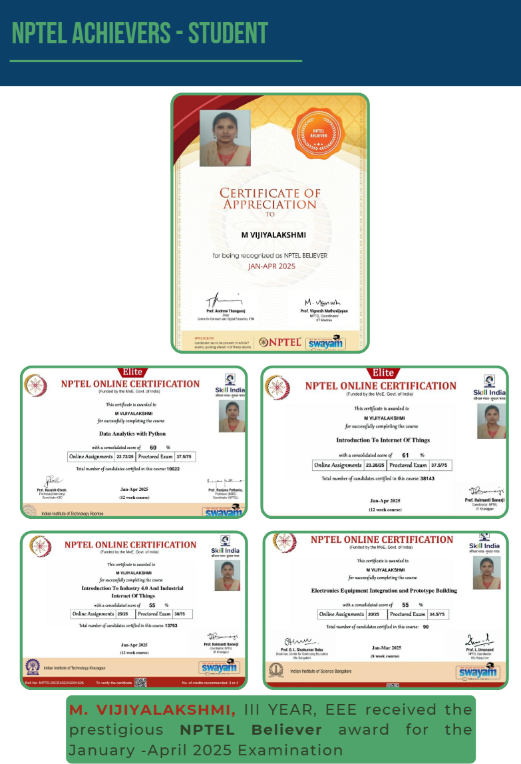
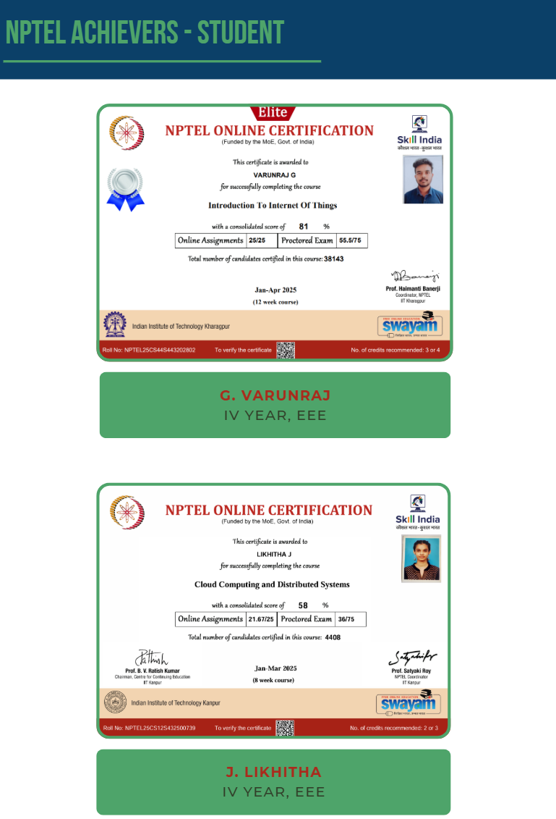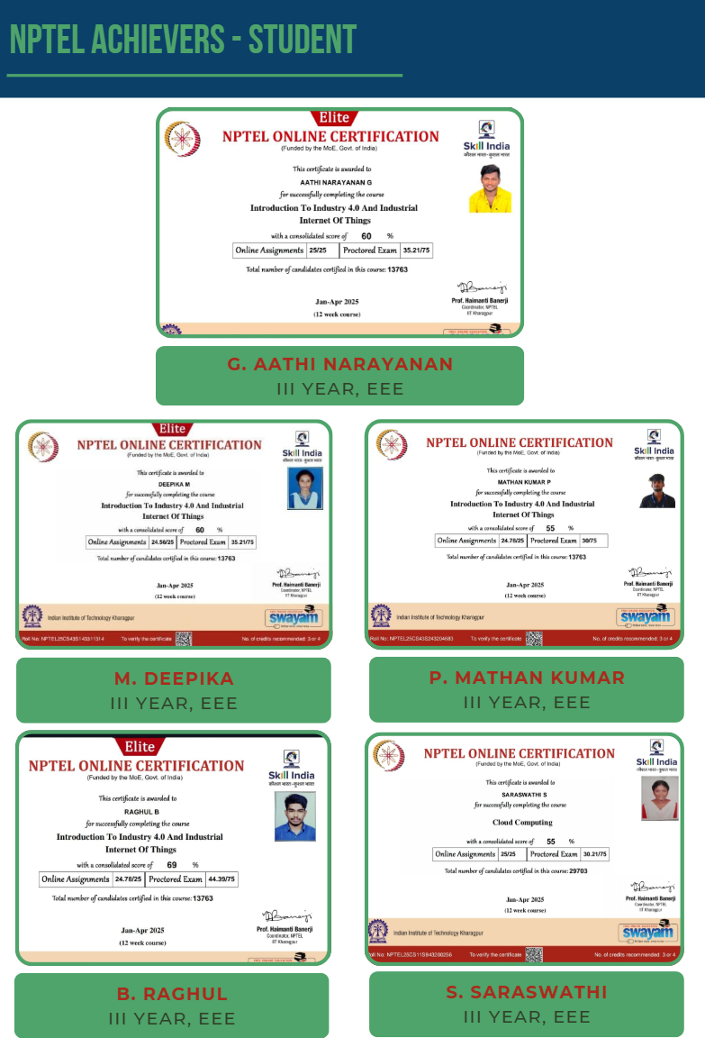
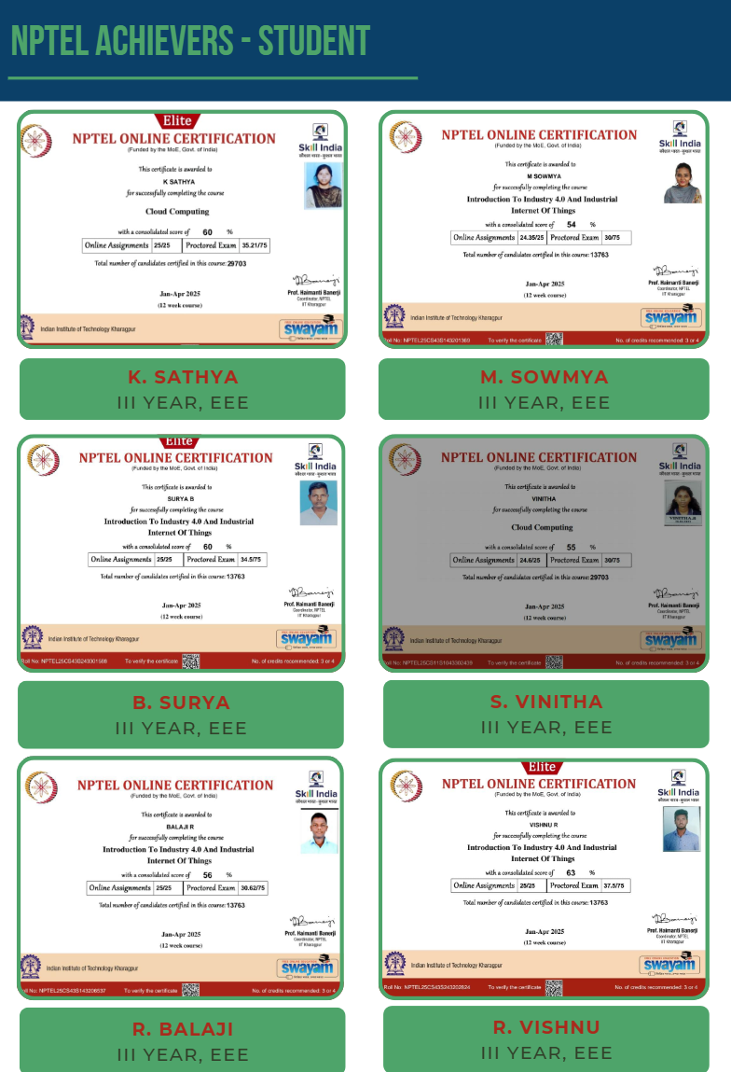
STUDENT Extra- CURRICULAR ACTIVITIES

SL.NO | NAME OF THE STUDENT | EVENT | VENUE | DATE
 | G. AATHINARAYANAN | Connexions | NPSBCET |  | 17th March 2025
 | M. DEEPIKA | Paper Presentation | SIMATS |  | 13th March 2025
 | M. DEEPIKA | Find the BGM | SIMATS |  | 13th March 2025
 | M. DEEPIKA | Connection | SIMATS |  | 13th March 2025
 | M. DEEPIKA | Connexions | NPSBCET |  | 17th March 2025
 | P MATHAN KUMAR | Connexions | NPSBCET |  | 17th March 2025
 | B RAGHUL | Paper Presentation | SIMATS |  | 13th March 2025
 | B RAGHUL | Find the BGM | SIMATS |  | 13th March 2025
 | B RAGHUL | Connection | SIMATS |  | 13th March 2025
 | N SARANYA | Paper Presentation | SIMATS |  | 13th March 2025
 | N SARANYA | Find the BGM | SIMATS |  | 13th March 2025
12. | N SARANYA | Connection | SIMATS |  | 13th March 2025
13. | N SARANYA | Connexions | NPSBCET |  | 17th March 2025
14. | S SARASWATHI | Paper Presentation | SIMATS |  | 13th March 2025
15. | S SARASWATHI | Find the BGM | SIMATS |  | 13th March 2025
16. | S SARASWATHI | Connection | SIMATS |  | 13th March 2025
17. | M SARUMATHI | Paper Presentation | SIMATS |  | 13th March 2025
18. | M SARUMATHI | Find the BGM | SIMATS |  | 13th March 2025
19. | M SARUMATHI | Connection | SIMATS |  | 13th March 2025
20. | SATHYA. K | Paper Presentation | SIMATS |  | 13th March 2025
21. | SATHYA. K | Find the BGM | SIMATS |  | 13th March 2025
22. | SATHYA. K | Connection | SIMATS |  | 13th March 2025
23. | S. SIBIRAJ | Paper Presentation | SIMATS |  | 13th March 2025
24. | S. SIBIRAJ | Find the BGM | SIMATS |  | 13th March 2025
25. | S. SIBIRAJ | Connection | SIMATS |  | 13th March 2025
26. | S. SIBIRAJ | Connexions | NPSBCET |  | 17th March 2025
27. | M SOWMYA | Paper Presentation | SIMATS |  | 13th March 2025
28. | M SOWMYA | Find the BGM | SIMATS |  | 13th March 2025
29. | M SOWMYA | Connection | SIMATS |  | 13th March 2025
30. | M SOWMYA | Connexions | NPSBCET |  | 17th March 2025
31. | B SURYA | Paper Presentation | SIMATS |  | 13th March 2025
32. | B SURYA | Find the BGM | SIMATS |  | 13th March 2025
33. | B SURYA | Connection | SIMATS |  | 13th March 2025
34. | B SURYA | Connexions | NPSBCET |  | 17th March 2025
35. | M THULASIKOTHANDAN | Connexions | NPSBCET |  | 17th March 2025
36. | M VIJIYALAKSHMI | Paper Presentation | SIMATS |  | 13th March 2025
37. | M VIJIYALAKSHMI | Find the BGM | SIMATS |  | 13th March 2025
38. | M VIJIYALAKSHMI | Connection | SIMATS |  | 13th March 2025
39. | S VINITHA | Paper Presentation | SIMATS |  | 13th March 2025
40. | S VINITHA | Find the BGM | SIMATS |  | 13th March 2025
41. | S VINITHA | Connection | SIMATS |  | 13th March 2025
42. | R VISHNU | Paper Presentation | SIMATS |  | 13th March 2025
43. | R VISHNU | Find the BGM | SIMATS |  | 13th March 2025
44. | R VISHNU | Connection | SIMATS |  | 13th March 2025
45. | R VISHNU | Connexions | NPSBCET |  | 17th March 2025
46. | J VISHNU | Paper Presentation | SIMATS |  | 13th March 2025
47. | J VISHNU | Find the BGM | SIMATS |  | 13th March 2025
48. | J VISHNU | Connection | SIMATS |  | 13th March 2025
49. | R BALAJI | Paper Presentation | SIMATS |  | 13th March 2025
50. | R BALAJI | Find the BGM | SIMATS |  | 13th March 2025
51. | R BALAJI | Connection | SIMATS |  | 13th March 2025
52. | SHASIDHARAN K | Workshop | SIMATS |  | 13th March 2025
53. | NIKITHA.N | Workshop | SIMATS |  | 13th March 2025
54. | PRIYANKA M | Workshop | SIMATS |  | 13th March 2025
55. | C Reshma | INVENT X | NPSBCET |  | 17th April 2025
56. | C Reshma | Technical Quiz | NPSBCET |  | 17th April 2025
57. | C Reshma | NET NEXUS | NPSBCET |  | 17th April 2025
58. | C Reshma | Electro Quest | MEENAKSHI SUNDHARARAJAN ENGINEERING COLLEGE |  | 17th April 2025
59. | M KANIMOZHI | INVENT X | NPSBCET |  | 17th March 2025
60. | M KANIMOZHI | Technical Quiz | NPSBCET |  | 17th March 2025
61. | M KANIMOZHI | NET NEXUS | NPSBCET |  | 17th March 2025
62. | M KANIMOZHI | Electro Quest | MEENAKSHI SUNDHARARAJAN ENGINEERING COLLEGE |  | 17th April 2025
63. | D DURGA | INVENT X | NPSBCET |  | 17th April 2025
64. | D DURGA | Technical Quiz | NPSBCET |  | 17th April 2025
65. | D DURGA | NET NEXUS | NPSBCET |  | 17th April 2025
66. | D DURGA | Electro Quest | MEENAKSHI SUNDHARARAJAN ENGINEERING COLLEGE |  | 17th April 2025
67. | S PAVITHRA | INVENT X | NPSBCET |  | 17th April 2025
68. | S PAVITHRA | Technical Quiz | NPSBCET |  | 17th April 2025
69. | S PAVITHRA | NET NEXUS | NPSBCET |  | 17th April 2025
70. | S PAVITHRA | Electro Quest | Meenakshi Sundhararajan Engineering College |  | 17th April 2025
71. | S VINITHA | Paper Presentation | RRASE |  | 24th April 2025
72. | SATHYA K | Paper Presentation | RRASE |  | 24th April 2025
73. | S SARASWATHI | Paper Presentation | RRASE |  | 24th April 2025
74. | ASHISH J | Paper Presentation | RRASE |  | 24th April 2025
75. | BUBESH S | Paper Presentation | RRASE |  | 24th April 2025
76. | DIVYA R | Paper Presentation | RRASE |  | 24th April 2025
77. | MURALI S | Paper Presentation | RRASE |  | 24th April 2025
78. | NIKITHA N | Paper Presentation | RRASE |  | 24th April 2025
79. | NISHA B | Paper Presentation | RRASE |  | 24th April 2025
80. | POTHIGACHALAM U | Paper Presentation | RRASE |  | 24th April 2025
81. | SABITHA S | Paper Presentation | RRASE |  | 24th April 2025
82. | SARAVANAN K | Paper Presentation | RRASE |  | 24th April 2025
83. | THIVYA S | Paper Presentation | RRASE |  | 24th April 2025
84. | VARUNRAJ G | Paper Presentation | RRASE |  | 24th April 2025
85. | KAMARAJ.K | Paper Presentation | RRASE |  | 24th April 2025
86. | SRILAKSHMI | Paper Presentation | RRASE |  | 24th April 2025
87. | BALAJI | Workshop | BHARATH INSTITUTE OF HIGHER EDUCATION AND RESEARCH |  | 7th April 2025
88. | PAKASH B P | Workshop | BHARATH INSTITUTE OF HIGHER EDUCATION AND RESEARCH |  | 7th April 2025
89. | VISHNU J | Workshop | BHARATH INSTITUTE OF HIGHER EDUCATION AND RESEARCH |  | 7th April 2025
93. | PAKASH B P | QUIZ | MADHA COLLEGE |  | 17th April 2025
94. | RAGHUL B | QUIZ | MADHA COLLEGE |  | 17th April 2025
95. | SIBIRAJ S | QUIZ | MADHA COLLEGE |  | 17th April 2025
96. | VISHNU J | Paper Presentation | DACE |  | 10th April 2025
97. | VISHNU J | Quiz | DACE |  | 10th April 2025
98. | VISHNU R | Paper Presentation | DACE |  | 10th April 2025
99. | VISHNU R | Quiz | DACE |  | 10th April 2025
100. | G. AATHINARAYANAN | Paper Presentation | DACE |  | 10th April 2025
101. | G. AATHINARAYANAN | Quiz | DACE |  | 10th April 2025
102. | M VIJIYALAKSHMI | Paper Presentation | DACE |  | 10th April 2025
103. | M VIJIYALAKSHMI | Quiz | DACE |  | 10th April 2025
104. | R BALAJI | Workshop | LEWAYTE |  | 28th November 2024
105. | BEL BENTO RAJAN | Workshop | VIT, Chennai |  | 9 th March 2025

FACULTY NPTEL Online CERTIFICATION Details

S.No | Name of the Faculty | Name of the course | Duration
1. | Ms.S.L Sreedevi | Introduction to Psychology | 8 Weeks
1. | Ms.S.L Sreedevi | Introduction to Soft Computing | 8 Weeks
1. | Ms.S.L Sreedevi | Introduction to Machine Learning | 12 Weeks
1. | Ms.S.L Sreedevi | NBA Accreditation and Teaching and Learning in Engineering | 12 Weeks
1. | Ms.S.L Sreedevi | Sensors and Actuators | 12 Weeks
1. | Ms.S.L Sreedevi | Data Mining | 8 Weeks
1. | Ms.S.L Sreedevi | Introduction to Internet of Things | 12 Weeks
2. | Ms.P.Aileen Sonia Dhas | Experimental Robotics | 4 Weeks
3. | Dr.S.Suganthi | Introduction to Internet of Things | 12 Weeks
3. | Dr.S.Suganthi | NBA Accreditation and Teaching and Learning in Engineering | 12 Weeks
4. | Ms.S.V.Nagalakshmi | EV - Vehicle Dynamics and Electric Motor Drives | 12 Weeks
4. | Ms.S.V.Nagalakshmi | Optical Wireless Communications for Beyond  5G Networks and IoT | 12 Weeks
5. | Ms.P.Priyadharshini | Introduction to Internet of Things | 12 Weeks

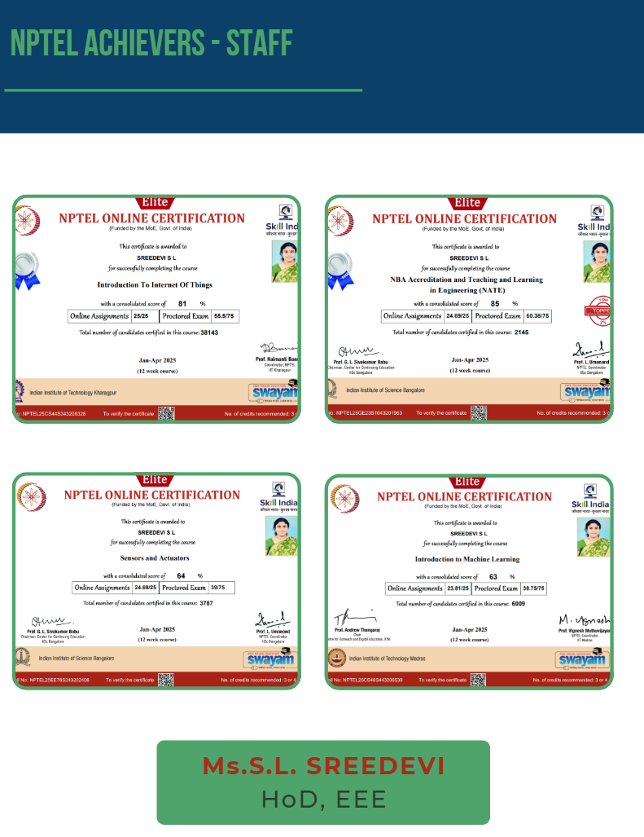
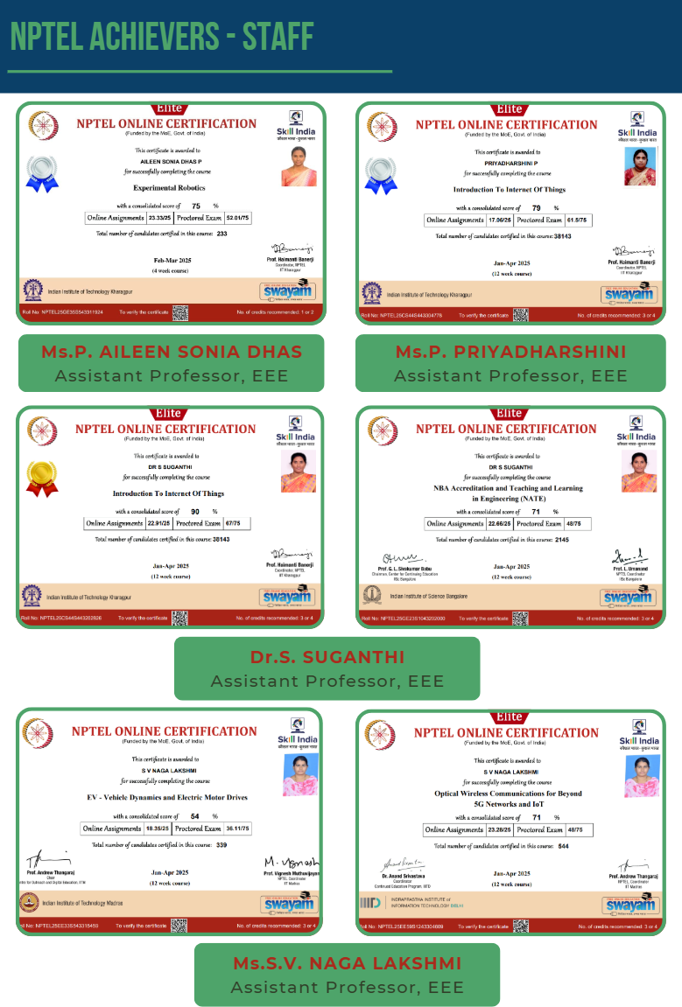

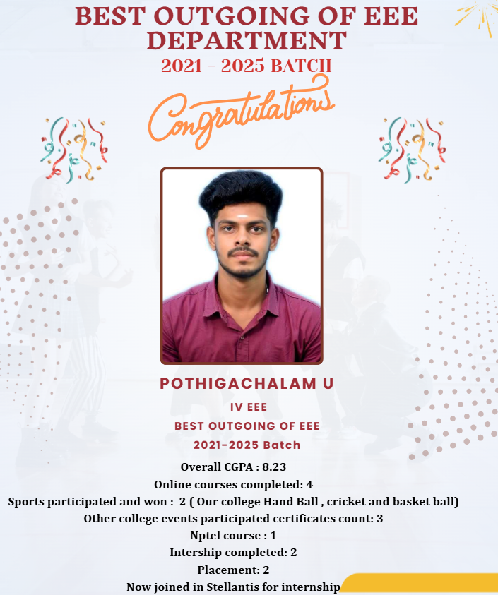
ANNA UNIVERSITY RESULT TOPPERS - NOV/DEC 2024

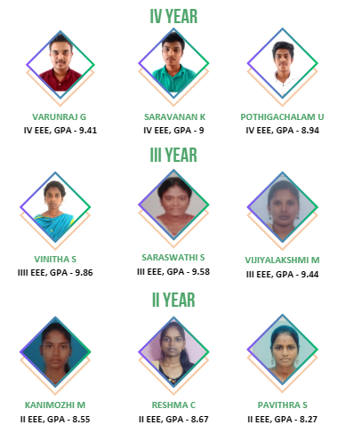
CAT & model exam toppers
CAT–I TOPPERS

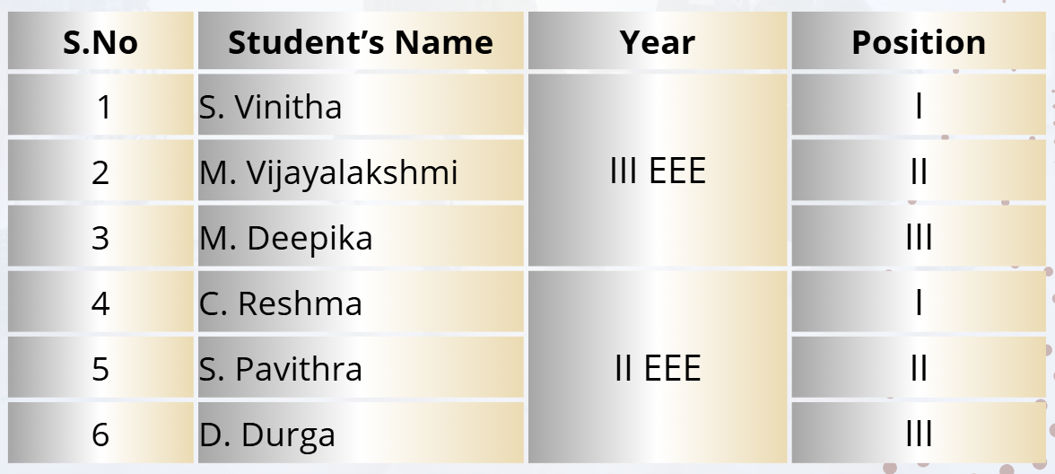
CAT–II TOPPERS

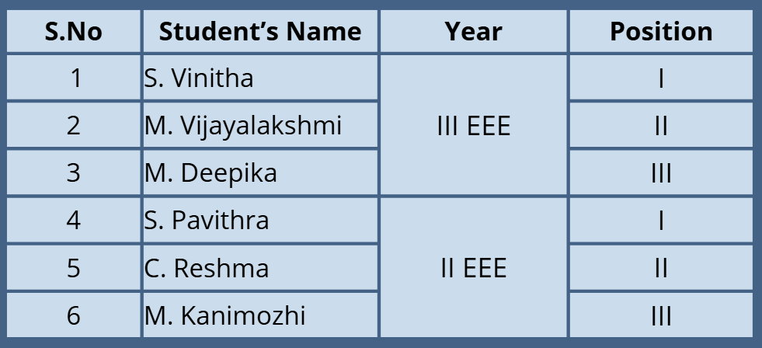
MODEL EXAM TOPPERS

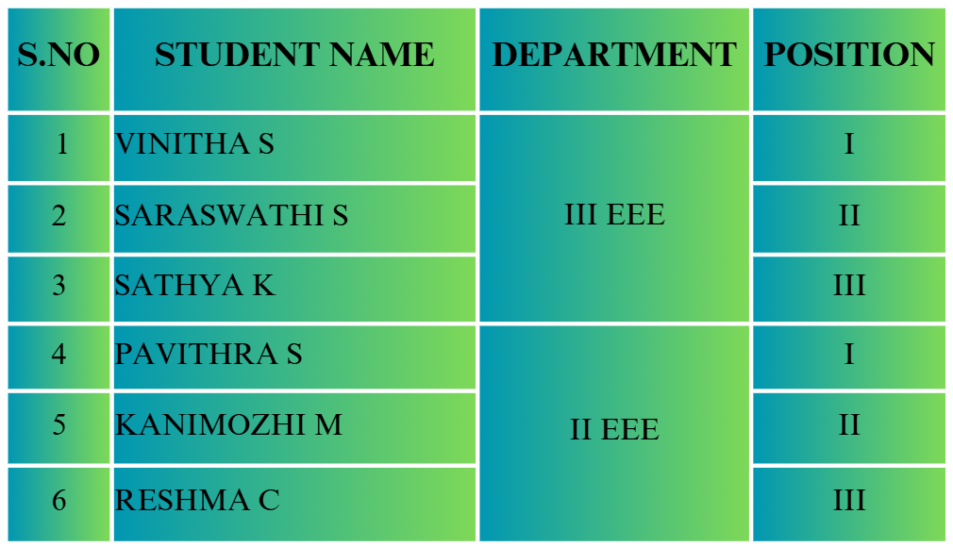

FACULTY ACTIVITIES

FACULTY ACHIEVEMENT

- Ms.S.L. SREEDEVI, HoD, EEE, received NPTEL Believer award during Jan - Apr 2025 in IIT, Madras.
- Ms.S.L. SREEDEVI, HoD, EEE, received NPTEL Discipline Star award in Computer science and Engineering discipline during Jan - Apr 2025.
- Ms.S.L. SREEDEVI, HoD, EEE, received NPTEL Discipline Star award in Electrical Engineering discipline during Jan - Apr 2025.
- Ms.S.L. SREEDEVI, HoD, EEE, received Excellence Award in reviewing of Journal of Engineering Research and Reports (JERR).

S.No | Name of the Faculty | Name of the Patent | Application No | Published Date
 | Ms. S.L. Sreedevi | Electricity access control system using passcode and IOT system | 202541043338A | 30/05/2025
 | Dr. V.Moorthy | Electricity access control system using passcode and IOT system | 202541043338A | 30/05/2025
 | Ms.P.Aileen sonia Dhas | Hybrid wind solar energy generation system utilizing integrated bsolar panel on integrated wind blade | 202541027618 | 25/03/2025

Patent Published
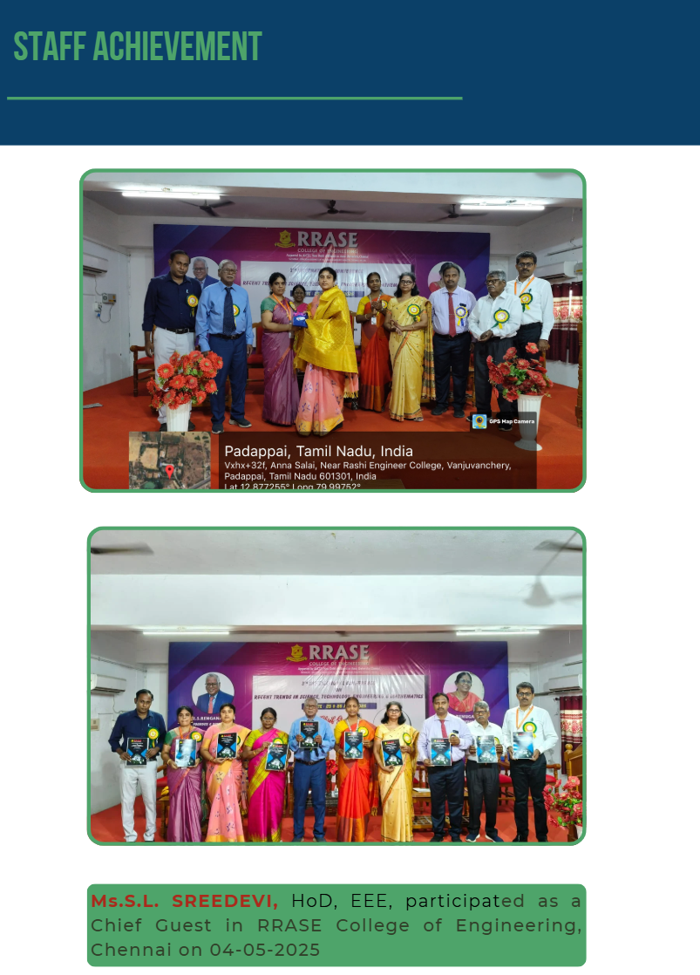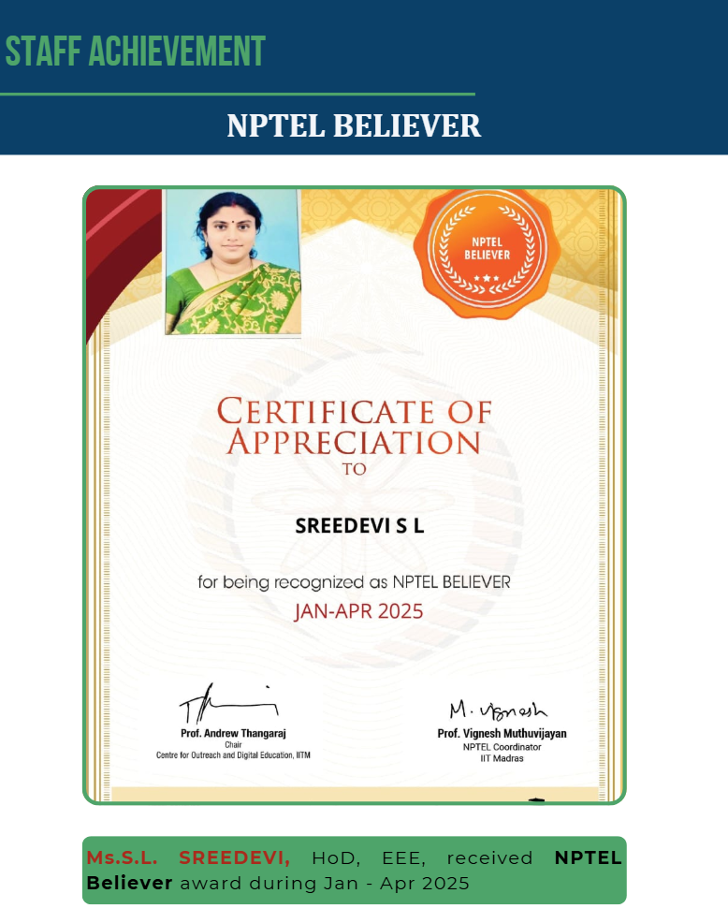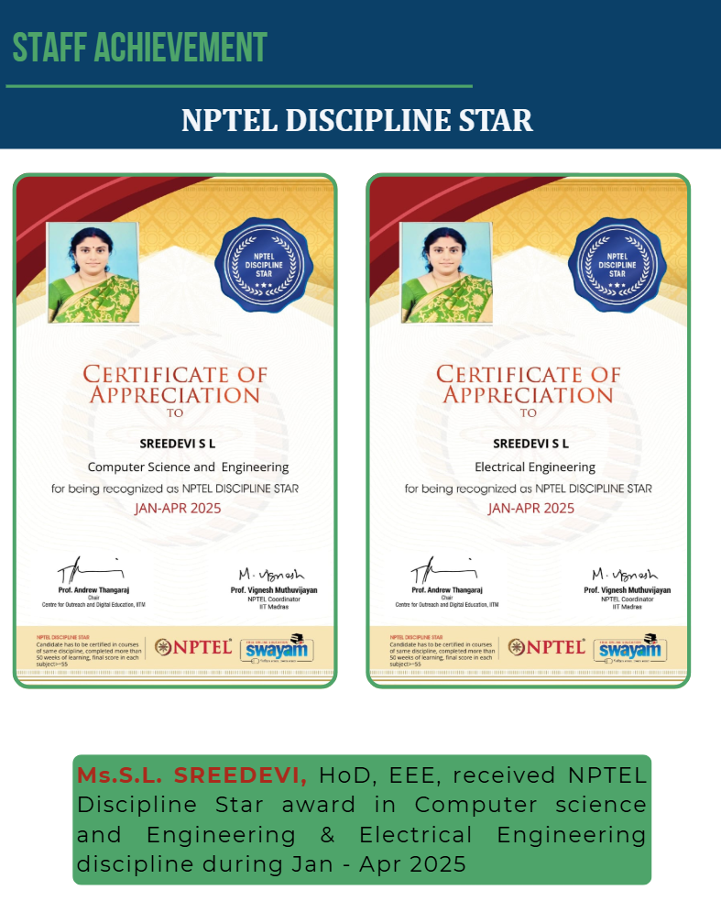
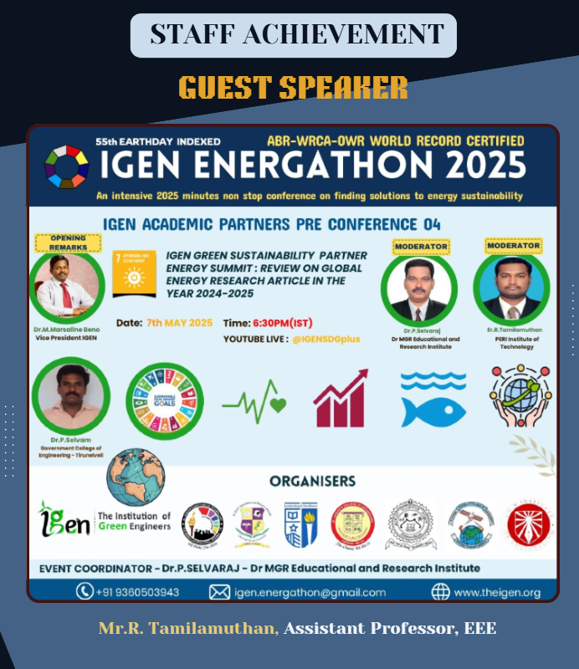
JOURNAL PUBLICATION
FACULTY ACTIVITIES
S.No | Name of the Faculty | Title of the Paper | Journal Details | Published Date
1 | Dr.S.Suganthi | Influence Of Stator Winding Turns On Performance Parameters Of Design Optimized Spoke-Inset Type Fractional Slot IPM Synchronous Motor | International Journal of Creative Research Thoughts | January 2025
2 | Ms.Nagalakshmi | Real time fleet tracking and Diagnostic system using CAN bus GPS | International Journal of Science and Technology  E-ISSN: 2229 7677 | July 2025  Vol. 16,  Issue .1

CONFERENCE PUBLICATION
S.No | Name of the Faculty | Title of the Paper | Journal Details | Published Date
1 | Ms.S.L Sreedevi | Optimizing Electric Vehicle Charging Through Integration of Flexible Energy Sources | 6th International Conference on Intelligent Communication Technologies and Virtual Mobile Networks (ICICV 2025) organized by Francis Xavier Engineering College, Tirunelveli, Tamil Nadu, India | 17/06/2025 to  19/06/2025
2 | Ms. S.L. Sreedevi | PID Switching Controller for Ripple Free Single Phase Interleaved Buck Converter. | 6th International Conference on Inventive Research in Computing Applications (ICIRCA 2025) organised by Department of Electrical and Electronics Engineering, RVS College of Engineering and Technology, Coimbatore, India | 25/06/2025-27/06/2025
3 | Dr.S.Suganthi | Enhanced V2G and GZV Operation Using Fuzzy Logic Controller and EMI Filtering in EV Chargers | 6th International Conference on Intelligent Communication Technologies and Virtual Mobile Networks (ICICV 2025) organized by Francis Xavier Engineering College, Tirunelveli, Tamil Nadu, India | 17/06/2025 to  19/06/2025
4 | Mr.R.Tamilamuthan | Enhanced V2G and GZV Operation Using Fuzzy Logic Controller and EMI Filtering in EV Chargers | 6th International Conference on Intelligent Communication Technologies and Virtual Mobile Networks (ICICV 2025) organized by Francis Xavier Engineering College, Tirunelveli, Tamil Nadu, India | 17/06/2025 to  19/06/2025
5 | Mr.R.Tamilamuthan | PID Switching Controller for Ripple Free Single Phase Interleaved Buck Converter. | 6th International Conference on Inventive Research in Computing Applications (ICIRCA 2025) organised by Department of Electrical and Electronics Engineering, RVS College of Engineering and Technology, Coimbatore, India | 25/06/2025-27/06/2025
6 | Mr.R.Tamilamuthan | Optimizing Electric Vehicle Charging Through Integration of Flexible Energy Sources | 6th International Conference on Intelligent Communication Technologies and Virtual Mobile Networks (ICICV 2025) organized by Francis Xavier Engineering College, Tirunelveli, Tamil Nadu, India | 17/06/2025 to  19/06/2025
7 | Mr.R.Tamilamuthan | IOT-Driven Solutions For Efficient Energy Management And Theft Prevention For Smart Meter | Conference of Proceedings of the 3rd International Conference on Optimization Techniques in the Field of Engineering (ICOFE-2024) Organized by Department of Computer Science and Engineering at K.S.R. College of Engineering, Namakkal, Tamil Nadu, India | 22/10/2024 to 23/10/2024
8 | Mr.R.Tamilamuthan | Design of Power Converter With Coupled Inductor For Aerospace Applications | InternationalconferenceIConREMOAS'25 on rebuild engineering and management operation in aviation science at Bharath Institute of Higher Education & Technology at Remo International College. | 04/05/2025

FDP/ Webinar/ STTP/ Workshop Attended
FACULTY ACTIVITIES

S.No | Name of the Faculty | FDP/ Webinar/ STTP/ Workshop | Name of the event | Conducted  by | Date/  Duration
1 | Ms. S.L.Sreedevi | FDP | Sensors and Actuators | NPTEL-AICTE | Jan - April 2025
2 | MS. S.L.Sreedevi | FDP | NBA Accreditation and Teaching and learning in Engineering (NATE) | NPTEL-AICTE | Jan - April 2025
3 | Ms. S.L.Sreedevi | FDP | Introduction to Psychology | NPTEL-AICTE | Jan - March 2025
4 | Ms. S.L.Sreedevi | FDP | Introduction To Soft Computing | NPTEL-AICTE | Jan - March 2025
5 | Ms. S.L.Sreedevi | FDP | Data Mining | NPTEL-AICTE | Jan - March 2025
6 | Ms. S.L.Sreedevi | FDP | Multidisciplinary Applications of artificial intelligence, IOT, and robotic Integration with Industry 5.0 | AICTE - ATAL | 07/07/2025  to  12/07/2025
7 | Mr.R.Tamilamuthan | FDP | Machine learning and IOT for Real time instrumentation in Electric and sustainable energy systems | SIMATS Tandalam, Chennai | 12/05/2025 to 17/05/2025
8 | Ms.S.V.Nagalakshmi | FDP | “Modern research trends in electrical, Communication, Signal processing, VLSI/MEMS “ organised by Department of management studies, SIMATS Engineering, SIMATS Tandalam, Chennai-602105 | NPTEL | 12/05/2025 to 16/05/2025
9 | Ms.S.V.Nagalakshmi | Workshop | AI in healthcare and Education | Indian council for Research and Development association with SKRG Academy | 20/06/2025
10 | Ms.S.V.Nagalakshmi | FDP | EV - Vehicle Dynamics and Electric Motor Drives | NPTEL | Jan-April 2025
11 | Ms.P.Aileen sonia Dhas | FDP | Machine learning and IOT for Real time instrumentation in Electric and sustainable energy systems | SIMATS Tandalam, Chennai | 12/05/2025 to 17/05/2025
12 | Dr.R.Kanthimathi | FDP | Machine learning and IOT for Real time instrumentation in Electric and sustainable energy systems | SIMATS Tandalam, Chennai | 12/05/2025 to 17/05/2025
13 | Ms.P.Aileen sonia Dhas | FDP | Experimental Robotics | NPTEL | Feb- March 2025
14 | Ms.P.Aileen sonia Dhas | FDP | Inculcating Universal Human Values in Technical Education | All India Council for Technical Education (AICTE) | 10/02/2025 to 14/05/2025
15 | Dr.S.Suganthi | FDP | Modern research trends in electrical, Communication, Signal processing, VLSI/MEMS | NPTEL | 12/05/2025 to 16/05/2025
16 | Mr.M.Sabareeswawan | FDP | Empowering Health care with AI: Advances, Applications and Future Directions | ATAL FDP Rajalakshmi Institute of Technology | 27-01-2015 to  01-02-2025

SUCCESS OF LIFE

Smile without mocking
Help without talking
Talk without wounding
Love without suspecting
Rest without lazing
Plan without scheming
Compete without hurting
Think without worrying
Thank without thinking…..

Our Editorial Team Members

- Mrs.S.LSreedevi, HOD/ EEE
- Dr.R.Kanthimathi, Asso.Prof/ EEE
- G.Varunraj, IV EEE
- S.Vinitha, III EEE

